Q1

1. B
2. B
3. B
4. D
5. A
6. D
7. C
8. B
9. C
10. A

Q2.

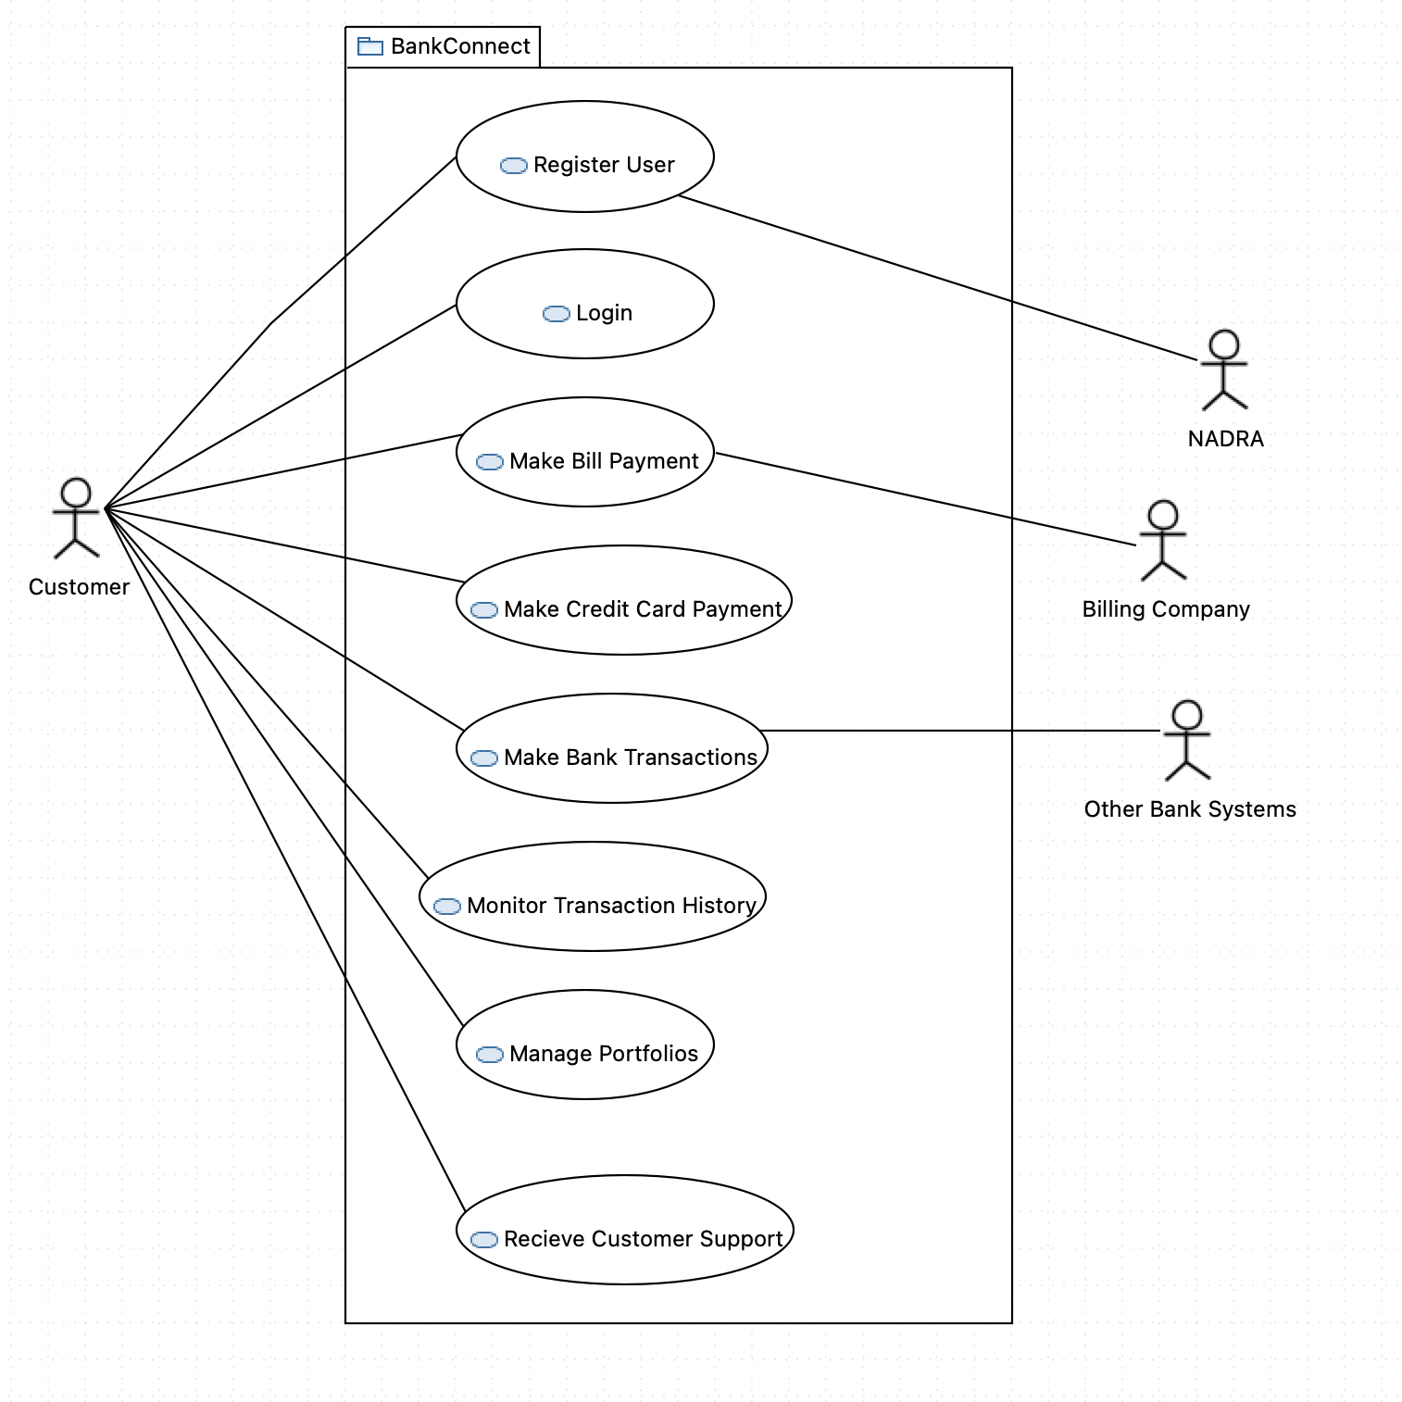

Q3.

UC1: Transfer Money

Actor: Customer

Type: Primary

**Description**: Customer logs in to BankConnect. After securely logging in, they choose the type of transaction, enter the necessary details for the account to transfer money to, verify their identity, review the transaction, and submit it. They receive confirmation and leave the system.

UC2: Register User

Actor: Customer

Type: Primary

**Description:** A new customer initiates the registration process on BankConnect by providing basic information, including their name, contact details, and a preferred username. The system sends this information to an external validation system to verify their identity using trusted databases. Once validated, the customer receives a verification code via email or SMS, which they enter to complete the registration process, ensuring secure and legitimate access to BankConnect's digital banking services.

Q4:

**a. Use case name:** Transfer Money

**b. Scope the system under design:** BankConnect

**c. Level:** User

**d. Primary actor:** Customer

**e. Stakeholders and interests:**

* Customer: To quickly and easily send money to others, both domestically and internationally, with competitive exchange rates.
* BankConnect: To provide a secure and reliable money transfer service to its customers, while generating revenue from transaction fees.
* Third-party payment processors: To facilitate international money transfers.

**f. Preconditions:**

* The customer must be a registered BankConnect user.
* The customer must have sufficient funds in their account to cover the amount of the money transfer plus any applicable fees.
* The recipient's bank account information must be accurate.

**g. Post condition:**

* The specified amount of money has been transferred from the customer's account to the recipient's account.
* The customer has received a confirmation of the money transfer.

**h. Main success scenario:**

1. The customer logs in to BankConnect and selects the "Money Transfer" option.
2. System asks for recipients details
3. The customer enters the recipient's bank account information, including their name, bank name, account number, and routing number.
4. System asks for amount to be transfered
5. The customer enters the amount of money they want to transfer and selects the desired currency.
6. The customer reviews the transaction details and confirms the transfer.
7. System generates an OTP and requests confirmation
8. The customer enters received OTP.
9. BankConnect processes the money transfer and the customer receives a confirmation.

**i. Extensions:**

**1a.** Login fails

**3a.** Recipients information is incorrect

**5a.** Not enough funds in customers account

**8a.** OTP is not received

**8b.** incorrect OTP is entered

Q5.

